The Lamplighter

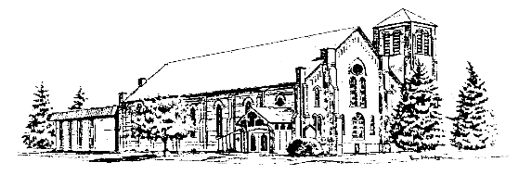**The United Church Canandaigua, NY**  **11 Gibson Street 585-394-0503**

**Worship Service 8:45 and 11:00 am, after Sept 4th**

**September 2022 Rev. Dr. Wade Allen**

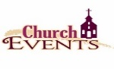

**Sept 4** – Guest preacher: Mark Slomski (final 9:30am worship service)

**Sept 5** – Office closed for holiday

**Sept 5** – Kayaking at Woodville, 1 pm

**Sept 6** – Stewards, 7 pm

**Sept 11** – Return to 2 worship services at 8:45 & 11:00 am

**Sept 11** – Sunday School Kickoff (all ages), 9:45 am

**Sept 12** – Trustees, 7 pm

**Sept 18** – 3rd Graders receive Bibles

**Sept 19** – Official Board, 7 pm

**Oct 2** – Exploring Membership Class, 9:45 am

**Oct 7-8** – American Baptist Biennial



**Table of Contents**

Church Family News …………………..………….…………Page 2

Pastor’s Page ………………………………………...…..…. Page 3

Mission News..……….………..… ……...…………………. Page 4-5

Remembering the Past…………………………………..……Page 6

Fellowship Events and Stewards Info…...…...……..………..Page 7

Adult Ministry………………………………………………. Page 8

Baptist Biennial Info…………………………………………Page 9

Youth News..…………………….……….……………..…...Page 10-11

Children’s Christian Ed News …………..………… …….…Page 12-13

Called to Care Canandaigua…………………………………Page 14-15

Calendars……………………………………………….……Inserted

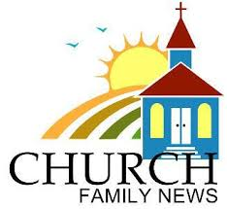**SPECIAL MEMBER UPDATES:**

Special Members are those in their 90s, and/or who are homebound, in nursing homes, or need temporary special care.

**Mary Vink’s birthday:** Sept. 4th, age 85.Maryjoined the church in 2016 and currently resides at Quail Summit Senior Center, where the wonderful staff helps her manage her dementia. Mary grew up in Mendon and worked at Kodak. After retiring, she worked part time at Wegmans. She likes to stay busy, playing BINGO and enjoying musical performances and other activities at Quail Summit.

NEW SPECIAL MEMBER:

**Sybil Amico:** b. 7/26/1936. Sybil has enjoyed attending our Sunday services over the last 10 years with her friends from Ferris Hills. Our prayers are with her, especially since she received a diagnosis of terminal esophageal cancer. She has decided not to seek treatment, preferring to enjoy her days with friends and activities as she is able. Sybil was a 1st grade teacher for 32 years, initially in her home state of N. Carolina, and then in Geneva and Pen Yann. “I loved the honesty and thought processes of the 6-year olds, they’re so sincere!” Sybil grew up on a farm where her dad grew cotton, produce, and raised livestock. She says that it was hard, physical work, but it was “a good way to grow up – in the country.” We’ll be waving to you when you watch us online each Sunday morning Sybil!!

Cards can be sent to Sybil at 208 Ferris Hills, Canandaigua 14424

A recent message from Sybil: *“****To the wonderful people at the United Church,*** *I want to express my sincere thanks for your prayers, cards, visits, and calls. They have helped me more than you will ever know. Thank you for your continued support. May God bless you all.”*

Updates for Special Members:

**Bill Adams:** A new room number; his address is: Ewing Continuing Care, Pines – Room 188, 350 Parrish St., Canandaigua, NY 14424

**Mary Vink** A new room number; her address is: Quail Summit, The Harbor - Room 160, Parrish St. Ext., Canandaigua, NY 14424

**Marilynn Frost:** She is now residing at the Ontario Center Nursing Home on County Complex Dr., however you may continue sending cards to her home: 3267 Hopewell Townline Rd., Clifton Springs 14432.

**REMEMBERING:**

Our prayers and sympathy are with **Karen Sanford**, whose brother, **Stephen Pratt**, passed away in June after a long illness.  Please keep the Sanford family in your prayers during this difficult time.

Our prayers and sympathy are with **Mary Lou Havens**, whose grandson, **Jeffrey Woods**, passed away unexpectedly in June. Please keep the Woods and Havens family in your prayers during this difficult time.

Our prayers and sympathy are with the family of **Jane LaPree**, who passed away on June 24th. Please keep her family in your prayers during this difficult time.

Our prayers and sympathy are with **Judy Bergstresser**, whose sister, **Nancy Evans**, passed away on July 16th. Please keep the Bergstresser and Davis families in your prayers during this difficult time.

**CELEBRATING:**

Congratulations to **Dan and Sonya Brooks** on the birth of their new grandson, **Nolan Matthew Brosamer**, on August 8th in Houston. His parents are Rebecca and Matthew Brosamer. Please keep the family in your prayers during this special time.

**---------------------------------------------------------------------------------------------------------------------------------------------------**

**MEMBER CARE:** If you are aware of anyone in our church family who is ill, having surgery, who had a death in the family, is having troubles in some way? Are you missing your neighbor who sits in the pew next to yours? O***r*** do you know someone who has a happy occasion to celebrate, please let us know!! The Staff works with the ***Outreach and Congregation Care Committee*** to connect with members of our church family who need encouragement and recognition. ***We care about you!*** Call the church office orCongregation Care Committee Chair: Sue Vadney, at (585) 739-8615



Having been in Canandaigua for just over 17 months, I am learning the ebb and flow of life in the Finger Lakes. A key aspect of life in this region is seasonal changes. Not only do we have significant shifts in weather patterns, but seasonal shifts impact our economy, daily patterns of life, food, clothing, leisure activities, and even our church schedule. We experience renewed energy and excitement for ministry with the change of seasons. Throughout this issue of the Lamplighter, you will read about program kick-offs and new ministry opportunities. I hope you will take the time to explore the various ways you can serve at The United Church this fall.

As we shift back to two worship services each Sunday (8:45 and 11 AM), we will transition to a sermon series on the book of Ruth. I am eager to explore this tremendous story with you. Let me encourage you to read the four chapters in the book of Ruth as you prepare for this series. If you would enjoy additional reading, let me recommend a book by Carolyn Custis James entitled *The Gospel of Ruth: Loving God Enough to Break the Rules* (<https://amzn.to/3A9XLlY>). James offers fresh insight into this timeless story. I will be using her book as I prepare for this series.

As we put away our summer gear and prepare for fall, may we take up the work of ministry at The United Church? Might God use us to carry out His work in our community? May we carefully discern how we might be involved and follow His leading into a new season of ministry?

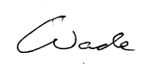

---------------------------------------------------------------------------------------------------------------------------------------

**September Worship Schedule**

* September 04 – (Mark Slomski) Faith in Action Part 2 (Hebrews 11:1-3)
* September 11 - Difficulties (Ruth 1:1-5)
* September 18 - The Cost of Following (Ruth 1:6–22)
* September 25 - Passing it On (Ruth 2:1-23)

-------------------------------------------------------------------------------------------------------------------

**Exploring Membership Class ~** We have great news for those of you who have been considering joining our church!  We will hold the next Exploring Membership Class on Sunday, **October 2nd** from 9:45-10:45 am.  We are excited and welcome you to attend and learn more about our programs and "our two denominations sharing a common love in Christ".  We hope you'll join us!  Please contact the church office (585-394-0503 or email at secretary@uccdga.org) if you are interested.

**----------------------------------------------------------------------------------------------------**

**Kids Choir** ~ We have decided to formally put together a kid’s choir and open it up to both boys and girls from 4th- 8th grade.

We plan to practice the 2nd and 3rd Sunday of each month for 15-20 minutes after 11:00 service.  We plan to have this group sing once at 11:00 church every 6 weeks or so.  Our first practice will be on September 11th, 2022 after the late service.

Please let us know if your child/children would be interested in this opportunity to sing to God’s glory in church.  If your child hasn’t sung with us in church before, we just need to meet with them for a few minutes.



God’s Blessings,

Nancy Burt-Preece and June Pettit

Summer 2022

* Eighteen of our youth have been able to attend Christian camps. Memories and new friendships were formed.
* A short-term youth (and adult chaperones) mission trip was completed. Look for the testimony on page 11
* Our missionaries are resourcing refugees, immigrants, and church leaders serving in their home countries.
* The shopping cart in the Welcome Center was filled with food and supplies each week.

**Coming soon**: On Saturday, October 8, American Baptist Global Servants, Anita and Rick Gutierrez, will be speakers at the ABC Biennial to be held at our church. These family doctors will share what God is doing in South Africa. Please take advantage of this opportunity and plan to join us as we hear their message.

~~~~~~~~~~~~~~~~~~~~~~~~~~~~~~~~~~~~~~~~~~~~~~~~~~~~~~~~~~~~~~~~~~~~~~~~~~~~~

**Missionaries supported**

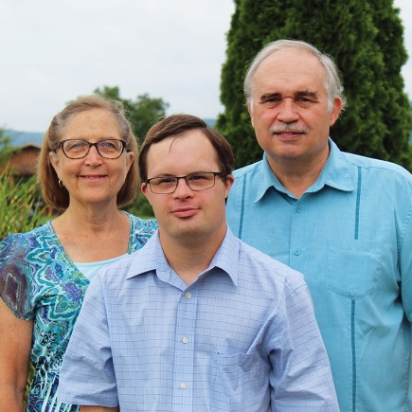**PRAYERS as they faithfully share God’s love and encouragement.**

**Patti and Tim Long**, continue serving in Baja California, Mexico. Patti ministers as a special education teacher and resource specialist at the Monte Horeb Baptist Grade School in Tijuana, a school that reaches out to some of the most vulnerable of the city’s young people, its children with special needs. Tim serves in leadership development with the Baja Baptist Seminary of Mexicali, teaching present and future church leaders in Baja California, and with IM partners in the Dominican Republic. He also serves as on-site coordinator and professor in Palmer Seminary’s online Masters in Theological Studies program in Latino ministries.

**Alethia and Ryan White’s** assignment in Berlin has expanded as the war in Ukraine evolves. Responsibilities have shifted since the pandemic began and they have also accepted the joint position of co-regional Presbyterian liaisons for Northern and Central Europe. They assist colleagues and regional partners in response to the Ukraine situation.

**Carlos Bonilla & Mayra Giovantti, the BGs**, mission focus is Discipleship, Short-term mission engagement, and Peace and Justice. The United Church’s 2017 mission trip to Bluefields, Nicaragua’s in country arrangements were provided by the BGs. They look forward to again visiting Canandaigua.

**Shelvis and Nancy Smith-Mather** continue in ministry with the South Sudan church. Their Spring 2022 Newsletter includes this quote.

“Eighteen months ago, when military forces exacted a “scorch and burn” campaign through our town, more than 70% of the population fled across the country’s border into Uganda. So too did the seminary in which I now teach. The civil war displaced my wife and children and the many families we had the honor of living in the community with for the last six years. Like those families, the school was forced to restart in a new context and a new country. The school was now based in Arua, a small town right outside the refugee camps in Uganda.”

They are connecting with the scattered refugee encampments with physical visits and via “ZOOM” encouraging and supporting the South Sudanese Christian leaders. Currently Shelvis uses electronic communication and commutes to the support and encourage the church in the refugee settlements. Nancy and their three young children are finding stability in their US home community.

**Thanks be to God for these talented and dedicated global partners.**

*Volunteers needed to serve at the following events.* Please share this info with any needing a boost in their grocery budget!

**Drive Thru Food Pantry**

At Zion Fellowship, 5188 Bristol Rd, Cdga

First Come, First Served, No RSVP required

**11am-1pm**

**Mondays: Sept 26, Oct 24, Nov 21, Dec. 19**

Questions or to Volunteer call

The Partnership for Ontario County 396-4554

Sponsors: CCIA (Canandaigua Churches in Action), The Partnership for Ontario County,

Zion Fellowship, Foodlink

**++++++++++++++++++++++++++++++++++++++++++++++++++++++++++++++++++++++++++++++++++++**

*Volunteers also needed for helping on this date.*

*Please share this info with anyone you know does not have dental insurance.*

**Supply a Smile Free Smile Day**

(for those without dental insurance)

**Free Smile Day** is **Sat., September 10** from 7am – 4pm at Lux Dental, 10 Brook St, Cdga

Sponsored by: CCIA (Canandaigua Churches in Action), Supply a Smile, in cooperation with Lux Dental

*Questions? See your CCIA rep – Cathy Bush 585-281-4602*

----------------------------------------------------------------------------------------------------------------------------------------

Our **RADA Fundraiser** is ongoing.  You can order RADA products any time by going to the link on the church website.  A percentage of every purchase goes to our Mission Trip Fund to assist those going on mission trips.  There are utensils, baking items, dishcloths [like the ones we used to sell at church], marinades, mixes for cheeseballs and dips, soups and sauces.  Order here and it will be delivered to your door, usually within a week. We thank you for your purchases.

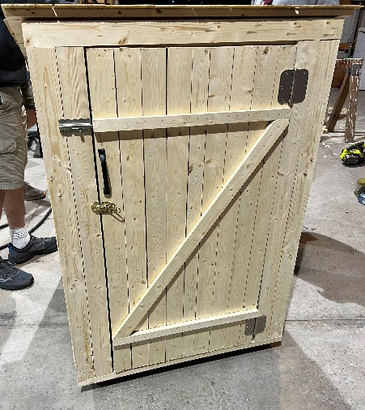**~~~~~~~~~~~~~~~~~~~~~~~~~~~~~~~~~~~~~~~~~~~~~~~~~~~~**

**Grace Payne’s Outhouse Project**

This project started as an idea for my Gold Award in Girl Scouts and now it is being fully put in action.

I built a 4ft tall, hollow outhouse. The point of the outhouse is to hold donations that the congregation buys. The donations will be taken to organizations such as The Salvation Army, CCIA, Care Net, etc.

The donations should consist of paper products such as:

* paper towels
* toilet paper
* wipes, etc.
* feminine hygiene (pads, tampons)
* baby items (diapers, baby wipes, lotion, baby powder, diaper cream)

The outhouse will be at our church for the month of September before I take the donations to an organization and move the outhouse to another church within the county.

Please consider donating throughout the month of September. Thank you ~ Grace Payne

**Remembering the Past:**

On November 20, 2022 The United Church of Canandaigua will be celebrating many milestone anniversaries. Leading up to this celebration, the Past Team (the team responsible for putting together the celebration), will be sharing with you several stories and historical excerpts about our church’s past and the reasons why we have so much to celebrate this year as a church family.

**Our Story #3 – Celebrating 50 Years!**

As we have followed Our Story over the past 150 years, it is exciting to see how much we have grown! The church originally built for the Presbyterian Congregation (Story #1-June Lamplighter), later grew to include the Baptist Congregation (Story #2-Summer Lamplighter). With all of the growth during the first 100 years, plans were put in place in 1972 to expand the church building to accommodate not only the current congregation and programs but any additional growth for the future. Isn’t it wonderful that in 1972, they were already planning 50 years ahead for us in 2022!

A building committee was stood up and planning underway for the new addition. The new addition, totaling roughly 6,000 square feet, would be referred to as the Christian Education building and would not only provide space for weekly Sunday School rooms for Nursery through sixth grade, but new office space, a pastor’s study, lounge space for junior high through adults, a library, chapel, and other facilities. The planning committee’s hope was that by building larger spaces, this would also encourage members of our community to come and use the space. “We see a need here as a church to provide some community services”.

Demolition of the church chapel (once located on the south side of the bell tower) and church manse (located on Gibson Street) began on July 15, 1972 making way for the new Christian Education building as well as additional parking lot space. Demolition of the two buildings continued throughout the summer and fall and on Friday November 10, 1972 a ground-breaking ceremony led by Reverend Fred Magley kicked off in celebration of the new expansion and future ahead.

In 2002, we found that again our United Church Congregation was outgrowing the current facilities. Planning began again to update the 30-year-old building with new and updated classrooms, handicap accessibility, new entrances to the sanctuary (including a Welcome Center), a chapel on the second floor and elevator access to the second floor as well as the basement. Construction for the last church addition was completed in 2004.

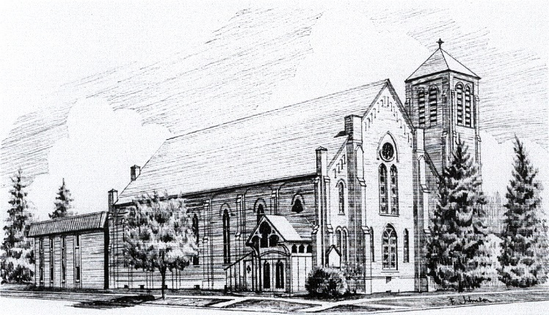Due to 50 years’ worth of future planning and building expansions, today our United Church facilities are able to provide many opportunities for adult and youth programs. Weekly Sunday School lessons, bible studies, prayer sessions, the Cause, Vacation Bible School, meetings, community events and programs, just to name a few, and we look forward to the next 50 years of future growth as a church, congregation, and community.

**Fellowship**

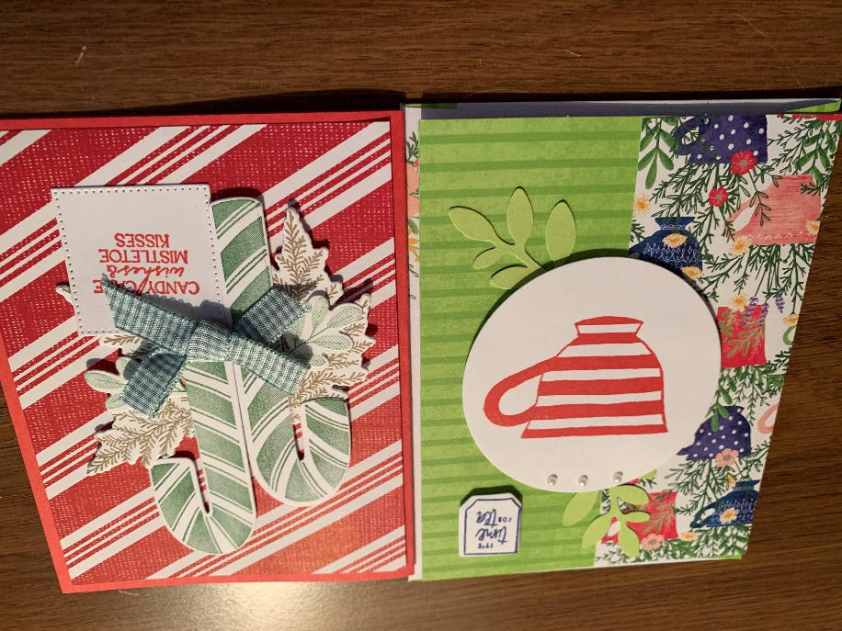The September **Stampin’ Up** class is scheduled for **Sept 17th** at 9:30 am in the Fellowship Room.  We will make the 5 cards pictured. Please call or email Sharon Meyer (585-924-8792 or shargmeyer@gmail.com) to sign up by Sept 11.

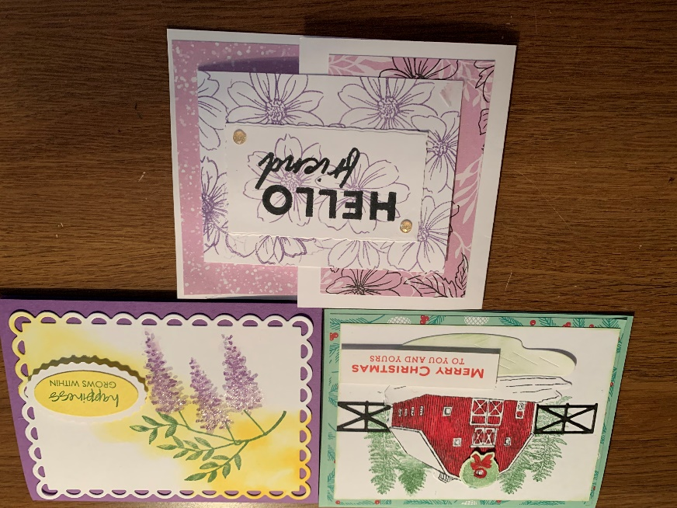

~~~~~~~~~~~~~~~~~~~~~~~~~~~~~~~~~~~~~~~~~~~~~~~~~~~~~~~~~~~~~~~~~~~~~~~~~~~~~~~~~~~~

**The United Church Praising Paddlers!!**

****Come join “The United Church Praising Paddlers” out on the water this summer with Canoes, Kayaks or SUPs, enjoying Gods beautiful creations together.

*“He leads me beside still waters, he restores my soul” – Psalm 23:2-3*

1 Final Event this Summer:

* Monday Sept 5th @ 1pm.  Canandaigua Lake West River-Woodville Boat Launch

Text Ali Boseck @ 585-729-3659 for more information. *Events will typically be 2hrs long and No Rain Dates will be scheduled.

----------------------------------------------------------------------------------------------------------------------------------------

**THE** **STEWARDS ASSISTANCE FUND** supports families in our congregation who need a little temporary financial help. These funds are supported through member donations and they are given to help purchase groceries, pay for medicine & medical bills, utilities, car repairs, and other essential household expenses. The recipients of these funds are very, very appreciative!!

If you, or someone you know in our church family needs assistance, please contact Virginia Holroyd at church or via email at: virginia.holroyd@uccdga.org. All requests remain completely confidential.

**-----------------------------------------------------------------------------------------------------------------------------**

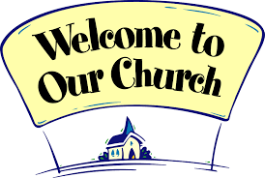**GREETERS of ALL AGES needed for BOTH SERVICES in SEPTEMBER:**

Greeters play an important role in extending hospitality in our church on Sundays. Greeters welcome people as they enter the church building, they hand out Bulletins, and they collect the offerings at each Sunday Service. This is a role where kids can help too!

******The **Sign-up Sheet** is on the **Church Office door**. Reminders and instructions are emailed the Friday before your scheduled Sunday. If you have any questions about being a Greeter, please contact Virginia Holroyd or any Steward. ***We really appreciate your service!***

**Adult Ministry** 

There is a spot for you this fall on Sunday mornings at 11 Gibson Street. Looking for folks who go through the same things you go through? Come and be fed by the One who knows what you need. We’ll have 3 groups up and running – an Old Testament study, a New Testament study, and a brand-new group *especially for parents*. All 3 groups will meet during Sunday School time.

1. Parents

Are Sunday mornings crazy at your house?

Do you have to put on your “happy face” walking into church after a crazy car ride?

Do you yearn for quality, faith-filled discussions with other parents

… and just time to breathe?

Then Come Join Us on Sunday Mornings

Where: Fellowship Room

When: 9:45 – 10:45

What to expect:

9:45–10:00 Chat and Snacks

10:00–10:30 Faith-Filled Discussion for Parents

10:30–10:45 More Chat & Snack Time

2. Book of John

We will use the Warren Wiersbe study of this New Testament book. One commentator describes John this way: “John’s Gospel is rather different from the other three.” And adds, “here focus is on the ‘signs’ of Jesus’ identity and mission and on lengthy, theologically rich discourses.” We will dwell in the chapters of John as he opens our eyes to this Savior of mankind.

3. The Feasts of Leviticus 23

Why did our Lord long ago spell out 7 feasts in peculiar detail for the Israelites? Because He had a plan! And that plan was Christ. We will study these less-familiar passages of Scripture, finding an appreciation of the arch of the Bible’s whole story, from the Old Testament into the New. And how the history of our faith is meaningful for our future in Him.

**Save the Date!** Our annual Adult Retreat will take place on Saturday, November 5, at Camp LeTourneau on the eastern shore of Canandaigua Lake. Our speaker will be Dr. Dana Goodnough. Watch for much more info this fall, so that you can register and bring a friend.

**Paul Johnson / Adult Education Director / 585-794-2746**

**American Baptist Churches of New York State Biennial Conference**

United Church Canandaigua, Oct 7 and 8 2022

(Presbyterian and United members please join us!!)

Our text for this Biennial says that we should “forget the former things” and not “dwell on the past…” (Isaiah 43:18-19) but I am reminded of this warning: “those who cannot remember the past are condemned to repeat it.” (George Santayana) and so while we should not dwell in the past, we do need to remember it, or we will indeed repeat it.

As Baptists we are a Bible people. Reading our Bible provides a way for us to remember the various ways in which God has delivered his people from one Exile to another!

Eugene Petersen reminds us that: *We do not begin life on our own…we enter a world…created by God, that already has a rich history and is crowded with committed participants…a world in which…surprising things keep on taking place.*

Petersen’s words remind me that as we begin life the world is already in motion. But even as the world keeps turning, God surprises us along the way. When we know God’s presence and live into God’s grace, we may be surprised at how God works through the gifts of Exiled people – a people embraced by God’s steadfast love and committed to God’s lovingkindness. And so as we live into God’s eternal presence, let us discern the “new thing” God is doing, and allow this year’s ABCNYS Biennial to bless us in surprising ways!

* Rev Wendy Depew Partelow, ABCNYS Board of Mission

Breakout sessions:

1. **Going Back to Go Forward?** The last few years have brought many challenges and traumas, and some have found it difficult to find hope. The Bible and historical church stories are full of people who faced seemingly hopeless situations and persevered. We will discuss some of these stories and lessons we can take from them as we seek a way forward in our own troubled times. – **Rev. Jonathan Lawrence**
2. **You Look Mahvelous…but You Sound Awful** A quick overview of the theology surrounding online worship along with tips for how to create engaging video presentations of worship. Whether you are streaming live or pre-recording worship, this breakout should help you to engage with your online viewers without breaking the bank. **– Rev. Ken McKenzie**
3. **Finding God & Ourselves in the Wilderness** The world we live in is becoming more and more a spiritual wilderness. The ancient celtic Christians lived, moved and followed Christ through the spiritual wildernesses of their day. We will explore what has been preserved from their rich history and writings and how we may find God and our true selves using some resources available today. **– Rev. Howard Maxson**
4. **A Biblical Look at Christian “Worship”** Discussion of what the Gatherings (“Come Togethers”) of the Body of Christ ought to be “about” and the appropriate “doings” of such. Discussion of Worship’s impact on Church revival and vitality. **– Rev. Jim Kerr-Whitt**
5. **Weaving Together Mission, Vision and Values** Can you explain your congregation’s mission? What about your organization’s values and vision? These elements exist in every organization but do not always work together to create a clear focus. Learn how to clarify these components for your church or nonprofit. Hear how ABCUSA is currently seeking to transform its own focus using these core elements.  **– Rev Dr. C. Jeff Woods**
6. **ABC Global Servants** Anita & Rick Gutierrez will share what God is doing in South Africa.

If you are willing to **volunteer** during this event, please see a member of the planning committee: Nancy or Bob Lamberson, Mary Lou Havens, Mary Beth Fortunato, Christy Allen, Mark and Robin Sheppard, Esther Pullis, Karen VanBlargan, or Dale Zajac. Volunteers can attend the conference for free. If you want to **attend** but are not willing to volunteer, please register at <https://www.abc-nys.org/abcnys-biennial.html>. We hope you will take part in this opportunity to attend a faith-based conference in our own church!!



Youth News!

Youth Director – Fun Facts

(about me)

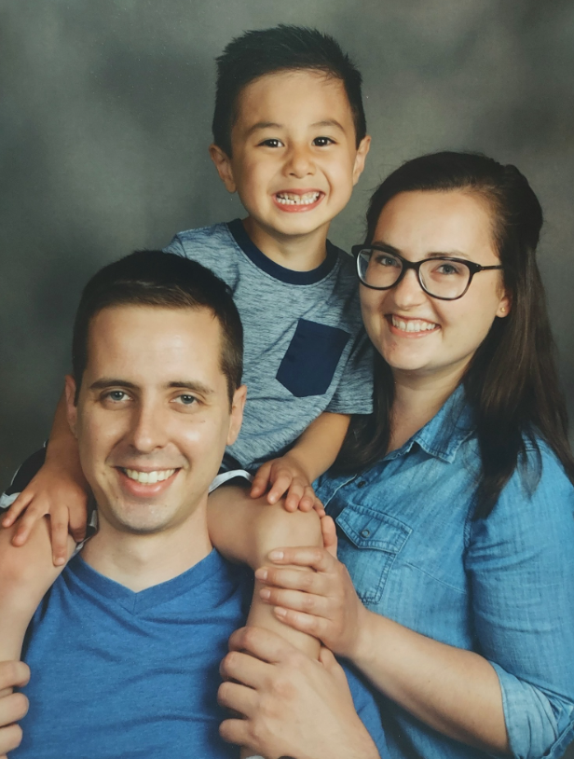

GROUP WorkCamp   
**Appreciation Event**  
Our Workcampers shared about their experience serving others in Dexter, Maine! Thank you to all the shareholders, prayer partners, families, friends and others who supported our team as they served others in the name of Jesus.  
  
**2023 Mission Trip**

**Where:** Woonsocket, Rhode Island   
**When**: July 16th – July 22nd, 2023 **Who**: United Church Youth & Adults are invited to sign up! *More details to come…save the date!*

Mark & Lauren Student Outings

Relationship-building is a key element to any ministry, and youth ministry is no exception. Mark & Lauren are looking forward to taking students out in small groups to build those connections as brothers and sisters in Christ!

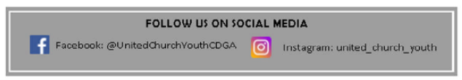

Upcoming Dates

**Aug 27th** – Cause Room Cleaning Event (10:00 AM – 12:00 PM)

**Sep 18th** – Cause Kick Off Event (5:00– 7:30 PM)

**Sep 25th** – The Cause (5 – 7:30 PM)

**Oct 2nd** – The Cause (5 – 7:30 PM)

**Oct 9th** – NO Cause *(Columbus Day Weekend)*

**Oct 16th** – The Cause (5 – 7:30 PM)

**Oct 23rd** – The Cause (5 – 7:30 PM)

**Oct 30th** – The Cause (5 – 7:30 PM)

**Nov 6th** – The Cause (5 – 7:30 PM)

**Nov 13th** – The Cause (5 – 7:30 PM)

**Nov 20th** – The Cause (5 – 7:30 PM)

**Nov 27th** – NO Cause *(Thanksgiving Weekend)*

**Dec 4th** – The Cause (5 – 7:30 PM)

**Dec 11th** – The Cause (5 – 7:30 PM)

**Dec 18th** – NO Cause (*Christmas Break*)

**Dec 25th** – NO Cause *(Christmas Day)*

**Jan 1st** – NO Cause *(New Year’s Day)*

*Be on the lookout for other events for 9th-12th graders!*

*When I was in high school…*

**Career Interests**: Law Enforcement

**First Job**: Cashier at Kmart

**Fashion Sense**: None… Basketball shorts/shirt

**What I did for fun**: Sports (basketball, soccer, rugby, running, MMA, fishing), camping with friends, keeping my first car squeaky-clean!

**Work Camp Testimony Natalie Cunningham July 24, 2022**  
Good morning, so as many of you know, we got back from our work camp trip last Sunday evening. We’ve been wanting to go on one of these mission trips for several years now, and I’d just like to thank you all for helping to make that happen.

During my time at work camp, I was able to establish relationships with new people, but even more so I was able to grow in my relationships with those in our youth group. It truly was a great bonding experience.

Work camp is an experience designed to help others, and although our group did a lot of work to help our residents, I found that in some cases, we get even more out of the experience than they do. This was certainly the case with me. As I was tearing apart and rebuilding a section of my resident’s deck, I got the chance to talk with him quite a bit. Steve and his wife Sharon are happily married, and live a very Christ-like lifestyle, but that wasn’t always the case. He shared openly with us that for the first 30 years of his life he was living a very worldly lifestyle, getting into things he shouldn’t have been getting into, and doing lots of things that at the time, he didn’t see a problem with. It took a near death experience to get him to see that there is more to life than just doing what feels good.

Steve is an avid fisherman and had a friend with a float plane who would fly him to these remote ponds to go fishing for the day. The plane regularly had maintenance issues, and on one of these trips, it went down. Plummeting headfirst into dense forest, things weren’t looking good for the 3 people on board. Somehow, miraculously, the plane landed on a tree that bent way over, slowing the plane down, and gently flipping it onto the forest floor. All 3 men walked away from the accident, but despite their remarkable condition, they were lost in the woods at dusk, with no sense of direction, and no hope of being rescued before morning. It was then that Steve heard a low humming sound in the distance. Neither of his friends heard this noise, but they decided to follow Steve towards the sound. After walking for SEVERAL MILES, they came across a truck on a dirt road, where they were able to get help and head for home.

I’m not sure what part of the story is more amazing - the fact that he survived the plane crash with no major injuries, the fact that he could somehow hear a truck from multiple miles away, or the fact that the truck stayed there, running for so long without moving. Either way, the combination of these events led Steve to pursue a relationship with Christ, who obviously had very big plans for his life.

After he had told me this story, I was blown away by the amazing ways that God moves and works in people’s lives. He then asked me “When and how did you get saved, Natalie?” I paused for a second and said “Well, to be honest I’m not sure if there ever was a time or place, I’ve been going to church since I was less than a month old, and that’s all I’ve ever known, I just sort of accepted it at face value. My testimony is pretty boring compared to yours”. His response really changed my perspective. He said that first of all, there’s no such thing as a boring testimony. Anytime anyone decides to live their life for Christ, that is a wonderful thing that should be celebrated. Second of all, the fact that my testimony is short, means that I was blessed with parents who raised me to follow Jesus from the very start, and for that I am so incredibly grateful.

I thought a lot about what he said, and realized that if my experience was like his, I would not have had the opportunity to even go to work camp, be a part of this wonderful church family, or work up at Beaver Camp like I am this summer. So my key takeaways from this trip are that I should always have gratitude for the blessings I’ve been given, and that even if your testimony seems boring, it doesn’t matter when, where, or how you got saved, **what matters is that we all get to be a part of the kingdom of heaven, and that is cause for celebration!!**

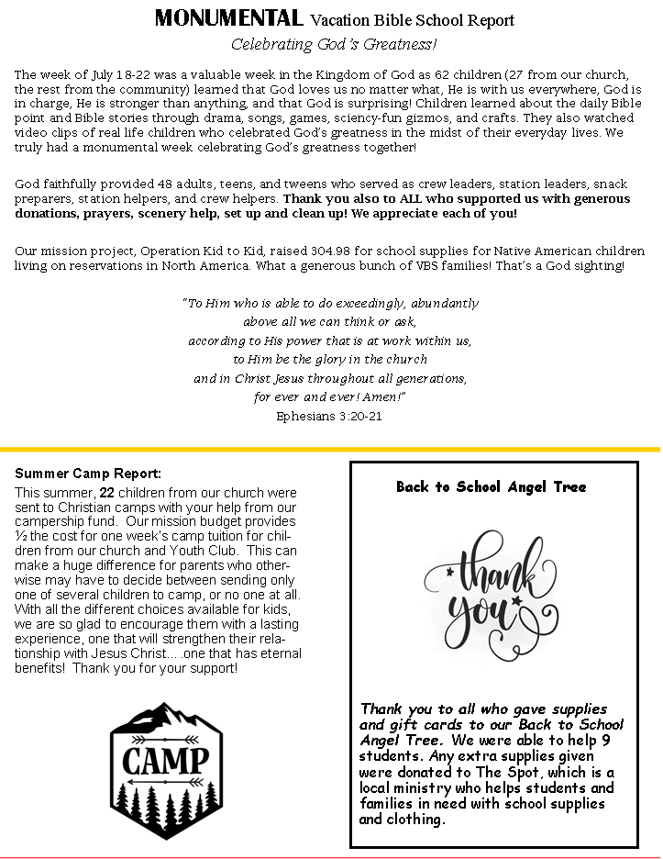

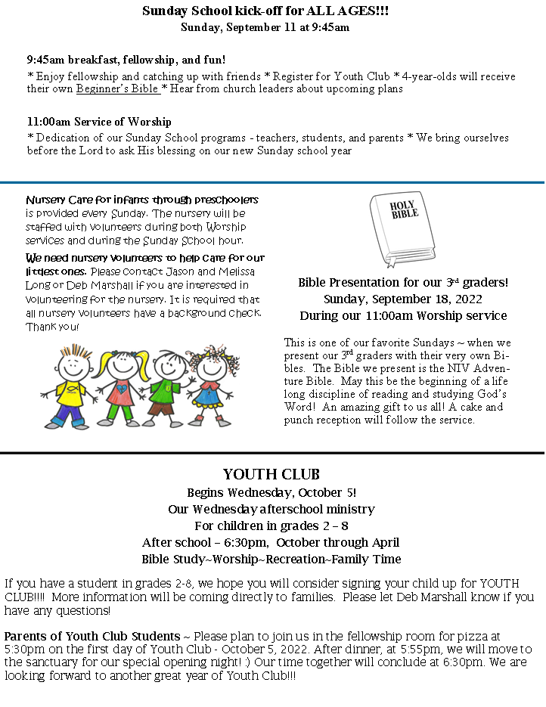

**We are “Called to Care, Canandaigua”** a group of individuals from local churches, service clubs and businesses coming together to welcome Ukrainian and other refugees to Canandaigua. Pastor Wade and I had been conversing about refugees early this year and his pastor’s group was as well. Our group formed, from those conversations in April, when Ulana Fuller and I invited others to come to a meeting and consider an initiative to welcome refugees here in our community. The idea resonated well with the seventeen of us at the meeting and we have been meeting monthly since then. We have had speakers from the NY20 Project, working to bring Ukrainians here under a humanitarian parole status, and World Relief bringing refugees from other parts of the world. Both agencies have offices in Rochester. We’ve been moving forward with solid plans; our group of supporters is growing; and we are now looking for volunteers to help in both large and small ways.

Our group is establishing the infrastructure needed to host refugee families. The particular need right now, is establishing a fund that can support family members for their first 90 days while *Called to Care, Canandaigua* helps them apply for work permits, social security, employment, driver’s licenses, and enroll in school and medical services. Refugee families arrive with little or no belongings. The fund will provide for housing, transportation and general living costs as the family becomes settled, independent, and a part of our community.

Once *Called to Care, Canandaigua* commits to hosting a Ukrainian family through NY20, a family could arrive within a matter of days. Establishing a support fund and a group of committed volunteers is our current focus.

A first fundraising event is planned for Thursday, September 15th. “Night for Ukraine” will be held at The Central on Main, 111 South Main Street, from 5-8pm with food available for purchase from participating downtown restaurants, live music, raffles, and a free will offering. We’re hoping you will mark the date on your calendars and make plans to support this initiative. Several of United’s mission committee members are already actively engaged. For more information please talk with either Ulana Fuller or Linda Werts. *“For I was hungry and you gave me something to eat, I was thirsty and you’ve me something to drink, I was a stranger and you invited me in.” Matthew 25:35.*

